### ****Key Features for Dynamic Components****

* Modular and reusable structure
* Optimized performance for faster rendering
* High adaptability and flexibility in functionality
* Scalable design for growing application needs
* Enhanced accessibility for all users

### ****Define Data Models****

**Examples:**

* Product: Includes name, price, category, and description
* Category: Tableware,chair and cutlery.

### ****Key Components:****

1. **Product Listing Component:**

• **Product Name:** The name of the product displayed for users.  
• **Price:** The price of each product.  
• **Image:** A product image to help users identify the product visually.  
This component helps to showcase a collection of products effectively in an organized  
manner.

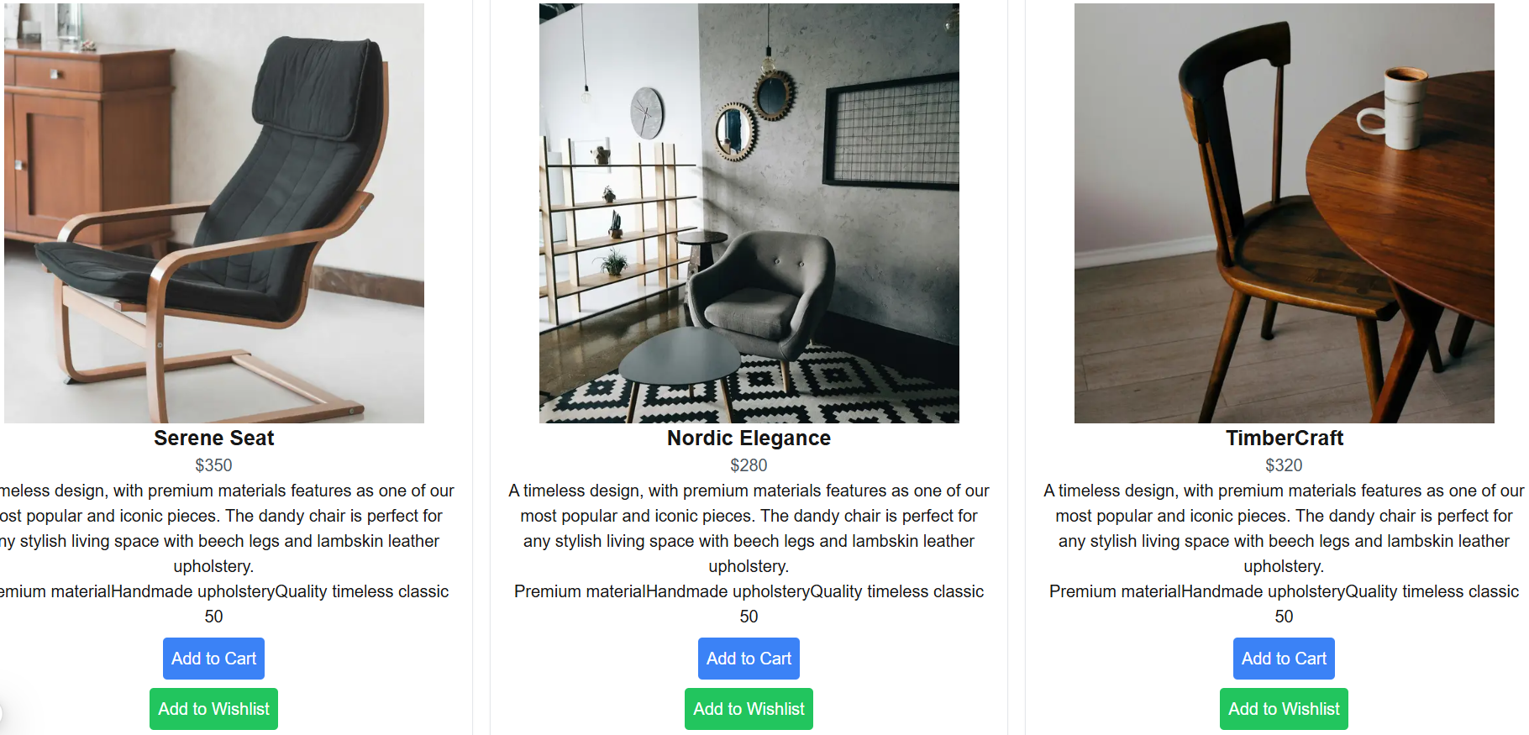

1. **Product Detail Component:**
2. Product Description: A detailed description that explains the features and  
   specifications of the product.  
   b. Price: The price of the specific product for purchasing consideration.  
   This component allows users to view in-depth information about a product they  
   are interested in.



**Screenshot of Header Component**





